Verifying your email address ensures your team has a good email address on file to communicate with you.
- Sign In to your team's TeamUnify SwimOffice website.
- If you see the below dialog, click Remind me later...
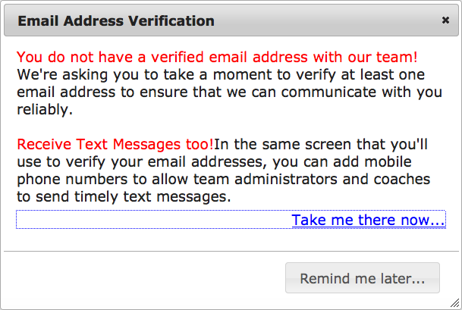
- In the side menu click My Account > My Account.
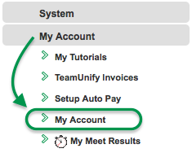
- Click the Unverified button above the email address.
- Click Yes to resend the verification email.
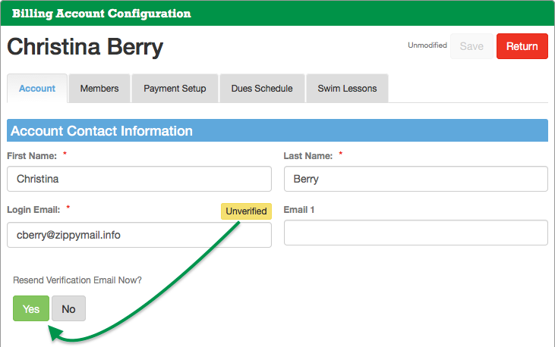
- Check that email account for a "Verify you email" message and open it.
- Click the link in it. If nothing happen when you click the link, copy it and paste it into your browser's address bar and press Enter.
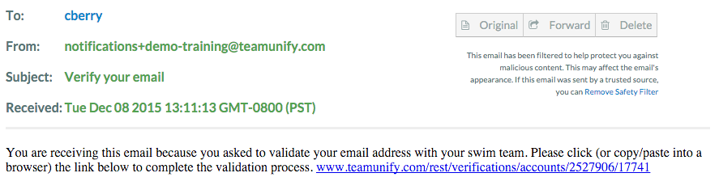
- You should see the message "Success! We have validated your primary email." in your browser. Close the browser tab.
- The next time you access your My Account screen you will see Verified in green above the email address (you may need to refresh the page).
